Getting Started with JPA & Hibernate

ST01: Getting started with JPA & Hibernate
- We will get introduced with JPA & Hibernate in this section
- We will build a simple JPA Application using the Modern Spring Boot Approach.
- We will do hands-on with JPA, Hibernate & Spring Boot
  - We will have a look into the world before JPA using JDBC & Spring JDBC.
  - We will understand why JPA or Hibernate & the difference b/w JPA & Hibernate.
  - How Spring Boot makes it very very easy to use JPA using Spring Boot Data JPA.

We will follow below approach to understand the above mentions:
- First we will create a Spring Boot Project with H2.
- Then create a COURSE table.
- Now, use Spring JDBC to play with COURSE table
- Then, use JPA and Hibernate to play with COURSE table
- Finally, use Spring Data JPA to play with COURSE table

ST02: Setting up a new project for JPA & Hibernate
- Create a new Project using Spring Initializer as we had created previously.

- Since we want to use JDBC, JPA & In Memory Database & to configure these, we need to add below dependencies for the same:
  - Spring Web (Starter Project for for Web Apps & REST APIs)

  - Spring Data JDBC - Persist data in SQL stores with plain JDBC using Spring Data.

  - Spring Data JPA - Persist data in SQL stores with Java Persistence API using Spring Data & Hibernate.

  - H2 database -
    - Provides a fast in-memory database that supports JDBC API and R2DBC access, with a small (2mb) footprint.
    - Supports embedded and server modes as well as a browser based console application.

- Select all the Dependencies & then generate the project.

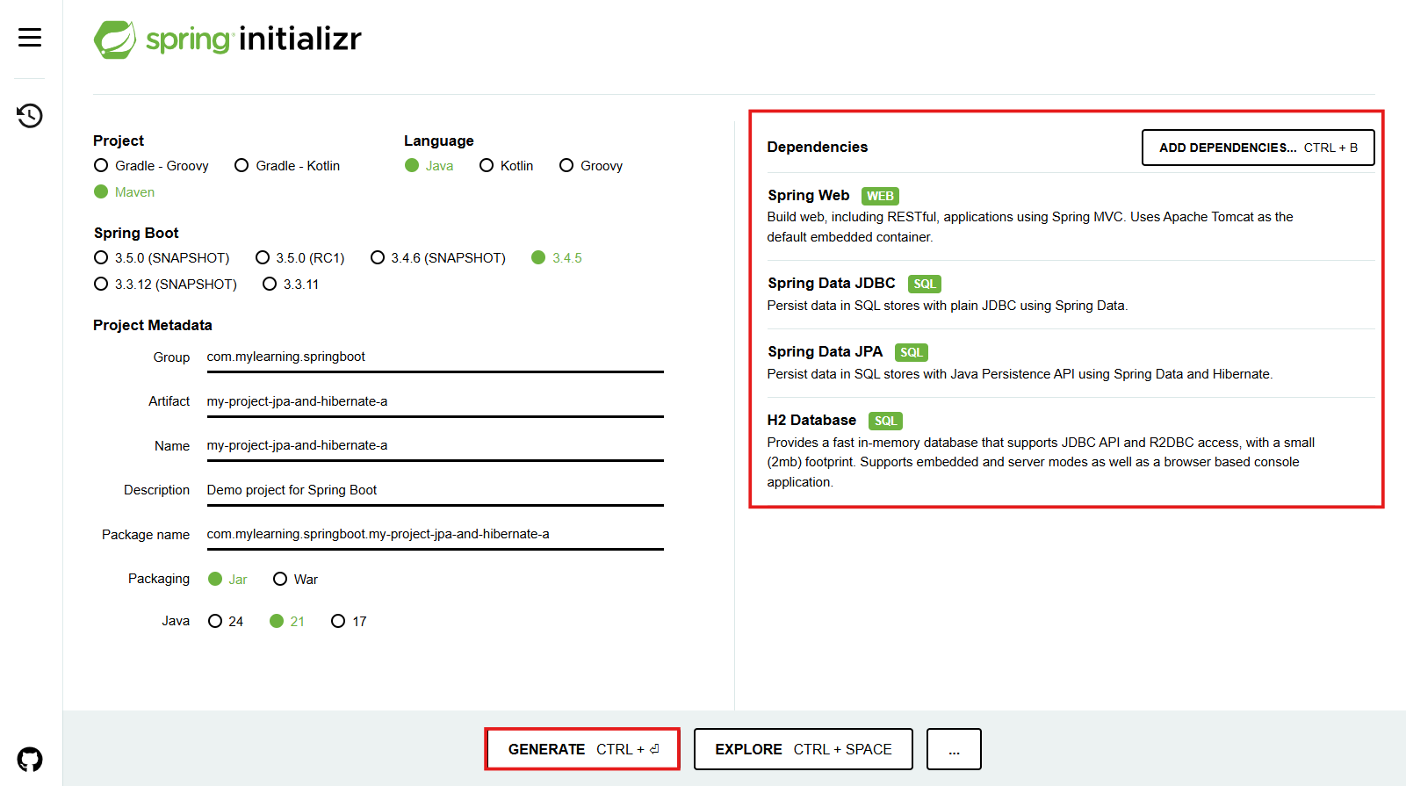

- Once the project is downloaded, unzip in the Java workspace & import it as a MAVEN project.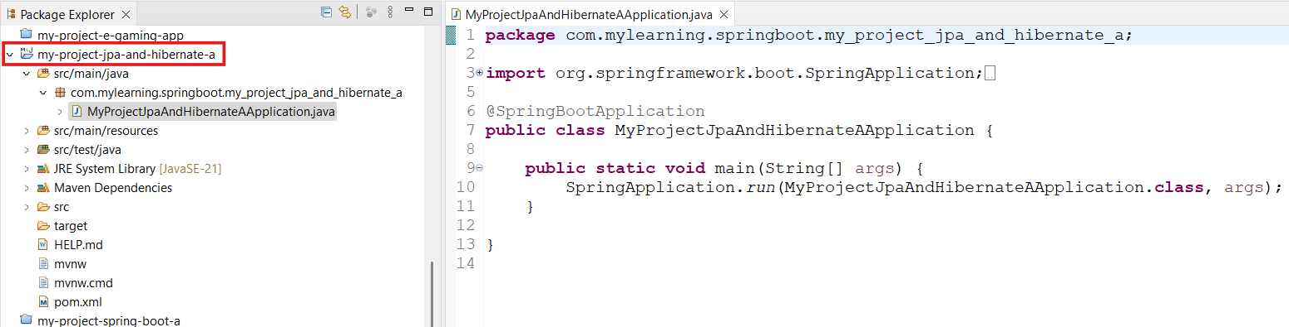
- If we check the pom.xml file, we can find all the dependencies included above.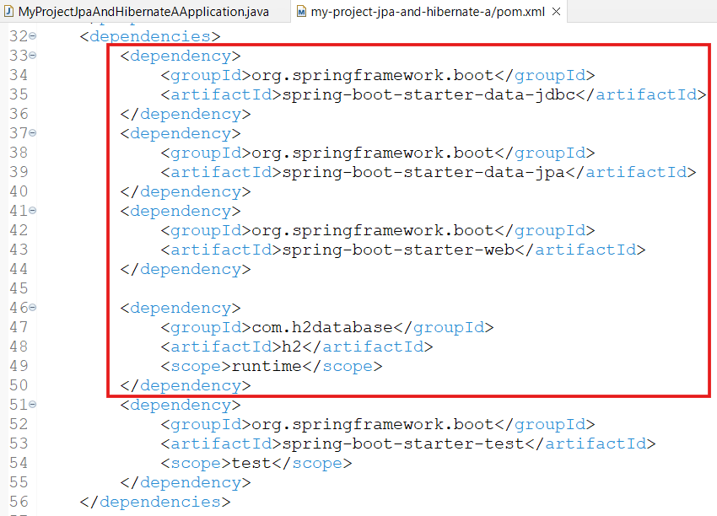
- We can launch the application & tomcat will be launched on the port - 8080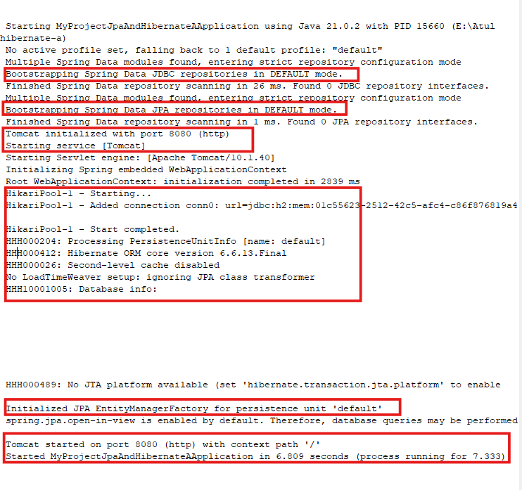
ST03: Launching up H2 console & creating ‘Course’ Table in H2
- When we launched the application, the H2 DB also launched & printed a URL for the same in the console(can be seen in the above screenshot).

- It starts with url=jdbc:h2:mem.

- HikariPool-1 - Added connection conn0: url=jdbc:h2:mem:01c55623-2512-42c5-afc4-c86f876819a4 user=SA

- We can enable H2 Console or enable the DB for access by configuring a property in application.properties file: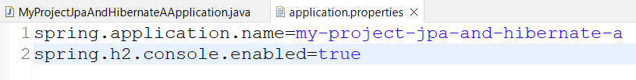

- Save & Restart or Relaunch the application.
  - New url=jdbc:h2:mem:82ec4359-1776-4fb3-882a-9676be0a6a1b

- We can see that sincere have not configured any specific url, that’s why it is getting dynamically generated

- So let's configure a static url, so that it doesn't change each time on application relaunch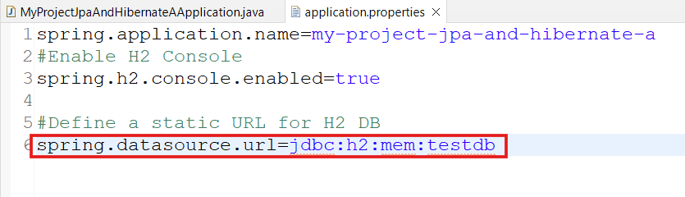

- Relaunch the application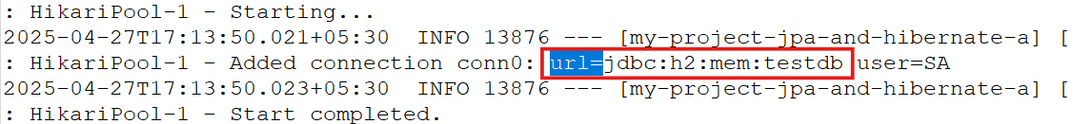

- We can see that the new connection has been created with the specified URL.

- To get the H2 Console, run the URL: http://localhost:8080/h2-console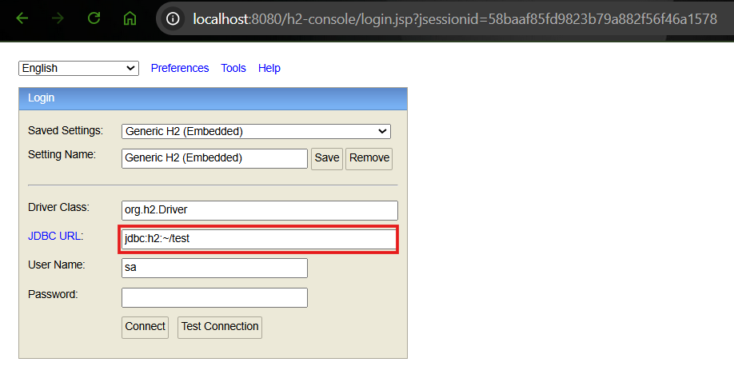
- Here, we will see a random url, which we need to update as per our configuration 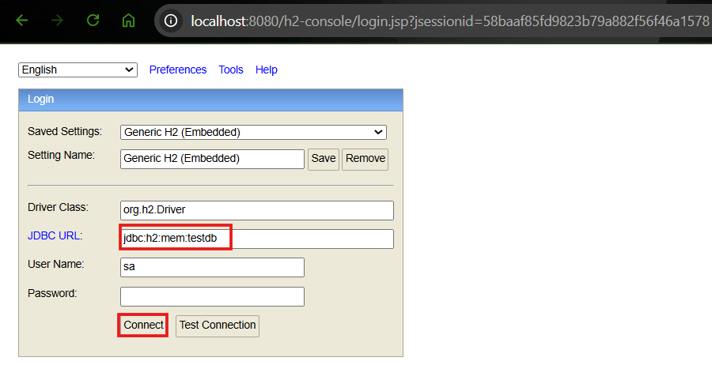
- Click connect, 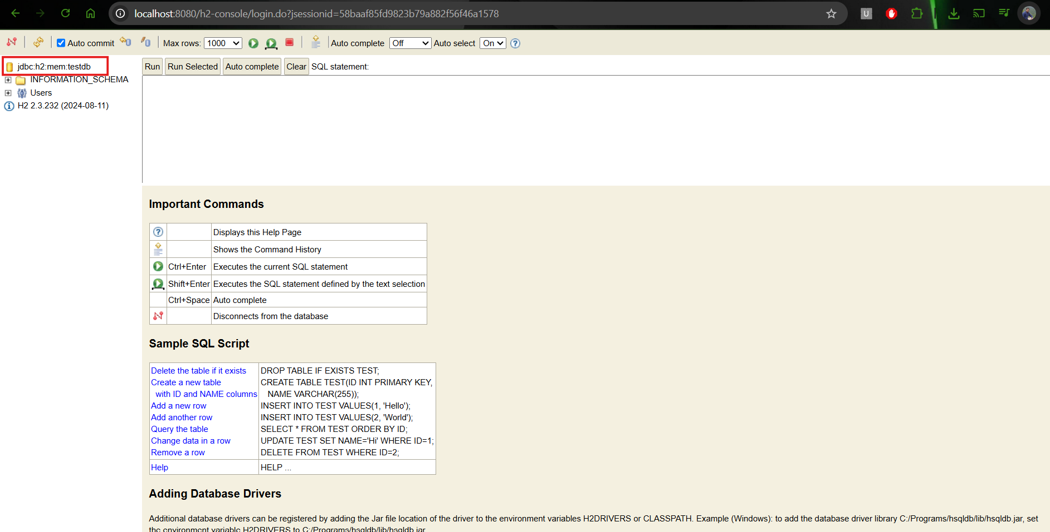
- As of now there is nothing in the DB. So, to be able to access JDBC, JPA, Spring Data JPA & Hibernate etc., we need to define some tables in H2.

- This can be done by defining a SQL file called schema.sql in the resources folder.

- Now relaunch the application & also refresh H2 Console. This should display the Course table defined 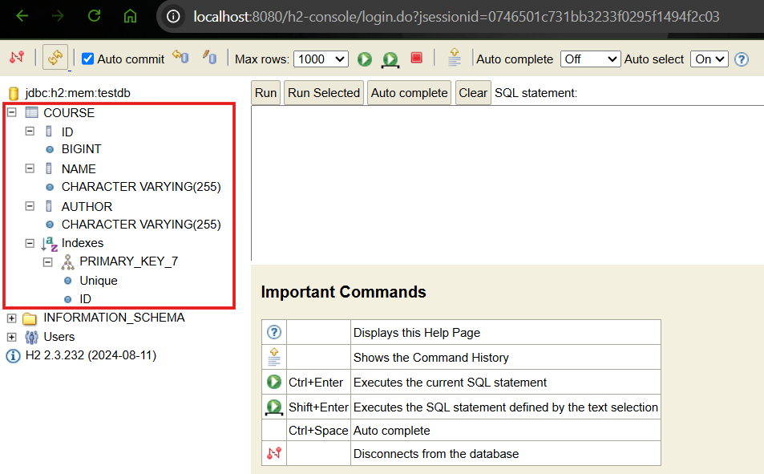

- In the query box we can create & execute different queries like - INSERT, SELECT, DELETE. If we have multiple queries written in the box, then we can select a specific query to be executed & select button - ‘Run Selected’ else Run button will work. 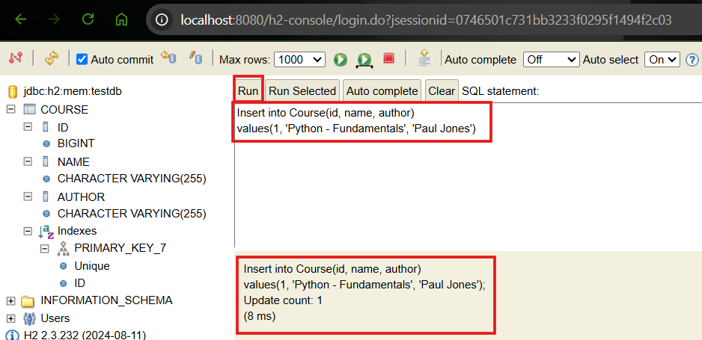
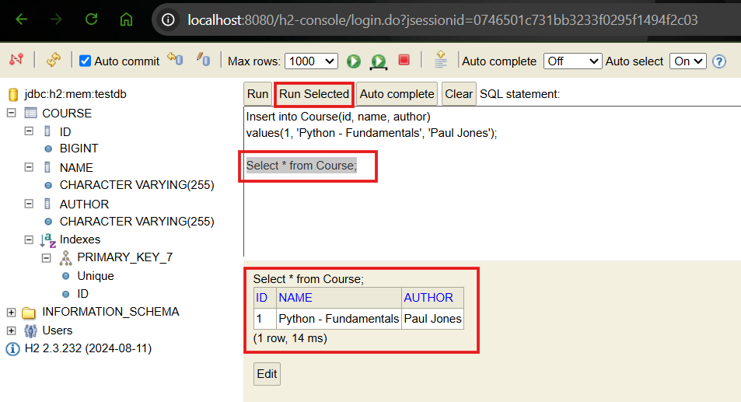
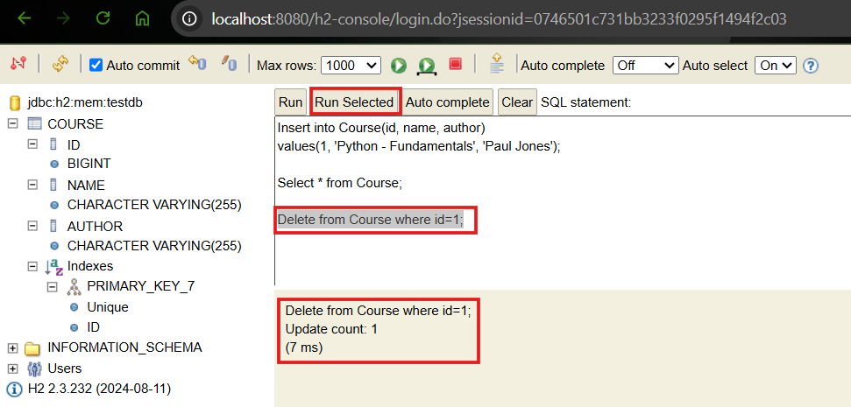

ST04: Getting started with Spring JDBC

Let’s try to insert data into the Course Table using Spring JDBC.

To use JDBC or Spring JDBC we need to write a lot of queries for data manipulation. But using JDBC we need to write a lot of java code as well. Whereas using Spring JDBC, very less code is required.

For Example:
Using JDBC below code
public void deleteTodo(int id) {
PreparedStatement st=null;
try {
st = db.conn.prepareStatement ("delete from todo where id =?");
st.setInt(1, id);
st.execute();
} catch (SQLException e) {
logger.fatal("Query Failed :", e);
} finally {
if (st != null) {
try {st.close();}
catch (SQLException e) {}
}
}
}

But with Spring JDBC, only below code is sufficient
public void deleteTodo(int id) {
jdbcTemplate.update("delete from todo where id =? ", id);
}

ST05: Inserting Hard Coded data using Spring JDBC

Now create a new class which will communicate with the Database annotated as ‘@Repository’ 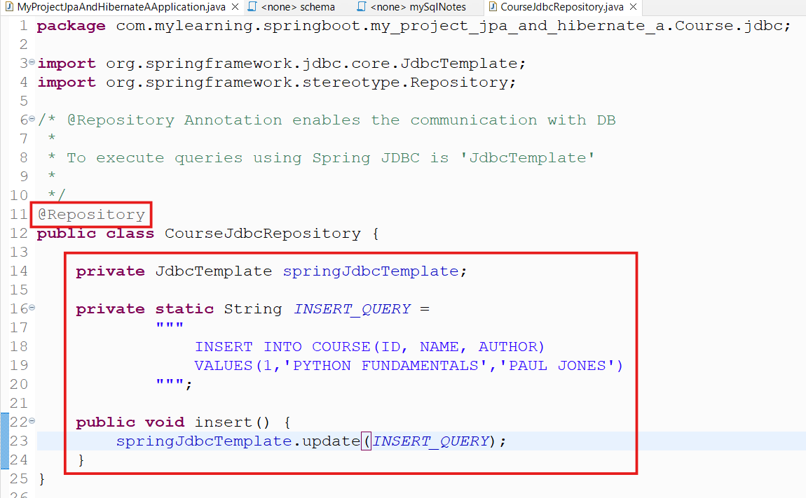
The update function enables us to perform other operations like - update, delete as well.
Now to automatically execute this operation on startup of the application, Spring Boot provides an options called Command Line Runner

To make it running at startup we need to implement an interface called CommandLineRunner.

It has a run method that executes the operations implemented in it during startup.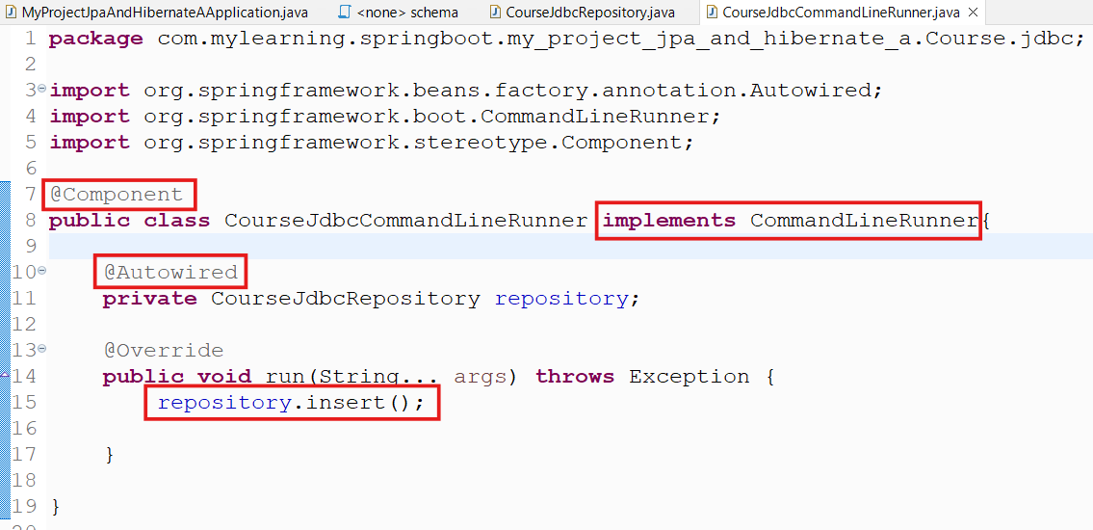

Now Launch the application.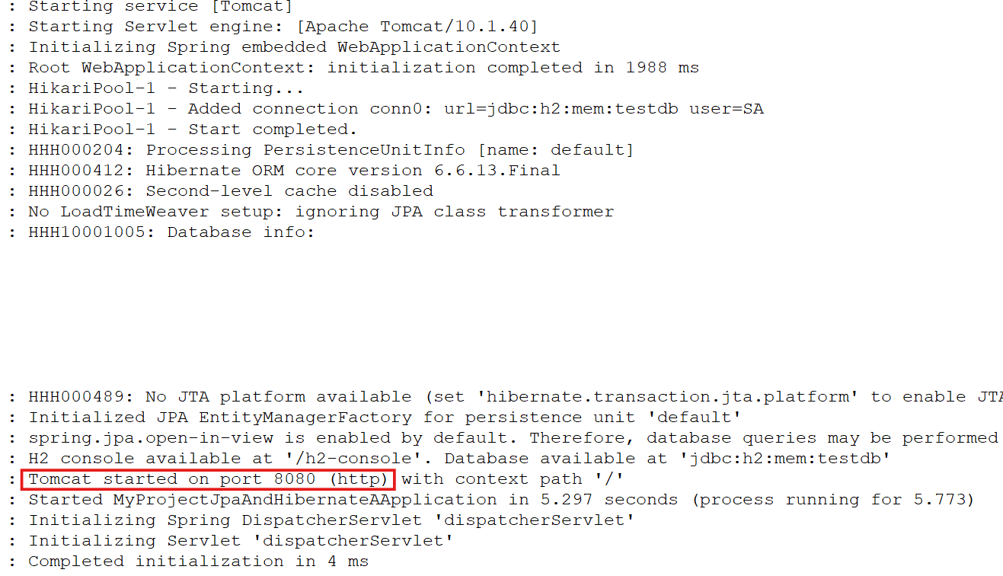

Lets connect the H2-Console & query to see if the data has been inserted on startup.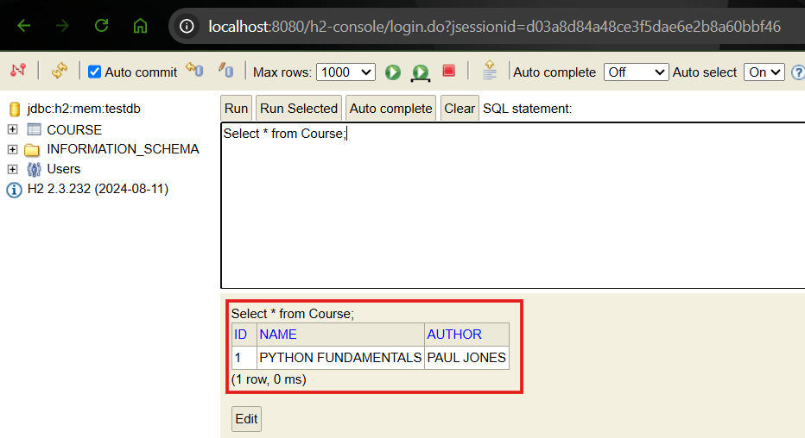

Here, we have seen that the data which is hard coded in the Repository class has been added in the Course table.

Now, let's make the Repository class more generic.

ST06: Inserting & Deleting data using Spring JDBC

- Update Repository class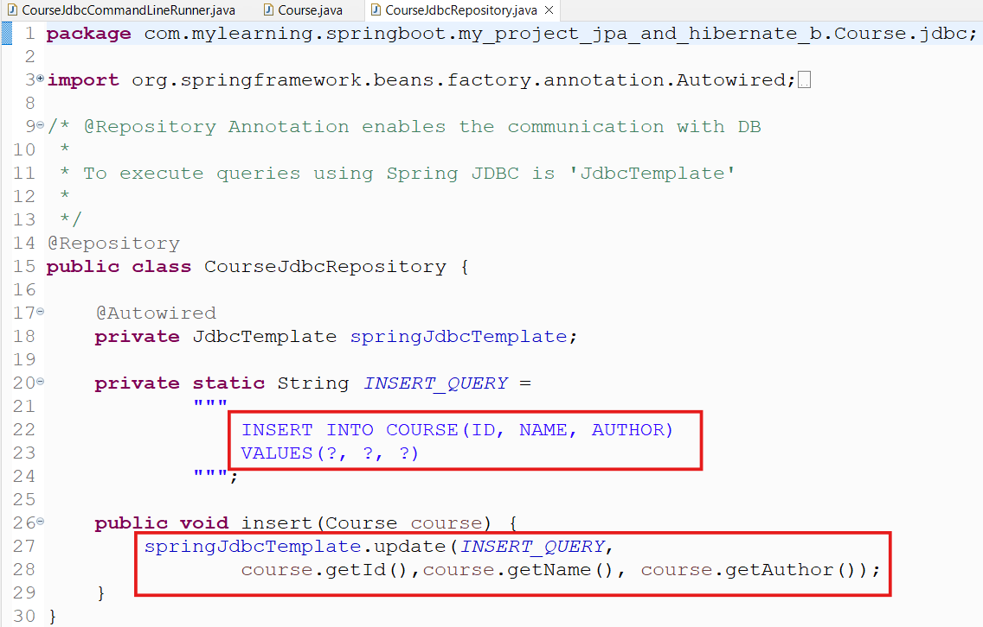
Since we need to pass the data externally(not hard coded), we need to make the Query generic. So that it can insert the data passed to it.

Also in the insert method, we need to add the getters for the specific fields in the same sequence in which the table or value clause is defined.

Any mismatch will lead to errors or exceptions.

- Create the Course class along with the constructors, getters & toString method
package com.mylearning.springboot.my_project_jpa_and_hibernate_b.Course;

import org.springframework.stereotype.Component;

@Component
public class Course {
private long id;
private String name;
private String author;

//No Argument Constructor
public Course() {

}

public Course(long id, String name, String author) {
super();
this.id = id;
this.name = name;
this.author = author;
}
public long getId() {
return id;
}
public String getName() {
return name;
}
public String getAuthor() {
return author;
}
@Override
public String toString() {
return "Course [id=" + id + ", name=" + name
+ ", author=" + author + "]";
}

}

- Update the JdbcCommandLineRunner class to pass the new instance of the Course class along with required arguments. 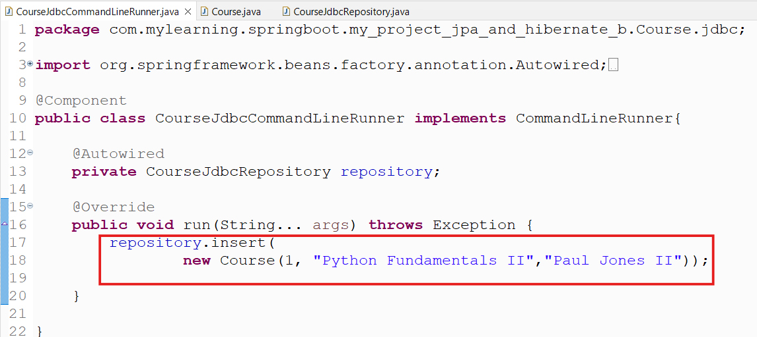

We can call the multiple instances of the insert method to insert more data one by one.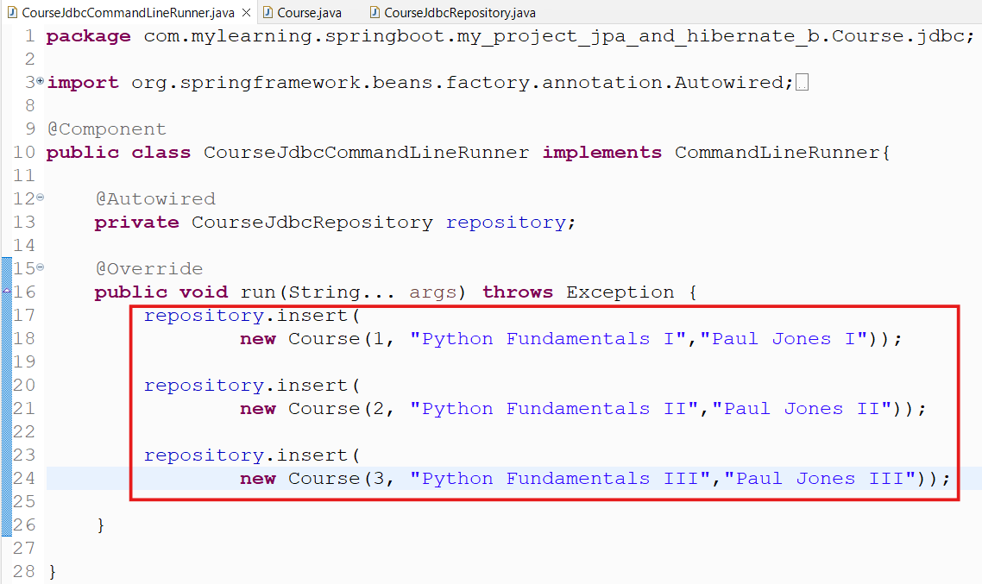

- Now Launch the application & execute select query to see the results: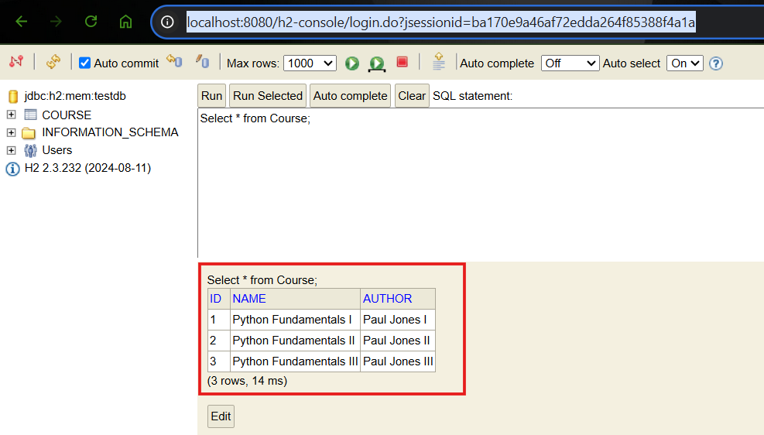
The expected data has been added in the Course table & returned through SQL.

- Now, we can also write delete methods to delete the data from the Course Table on startup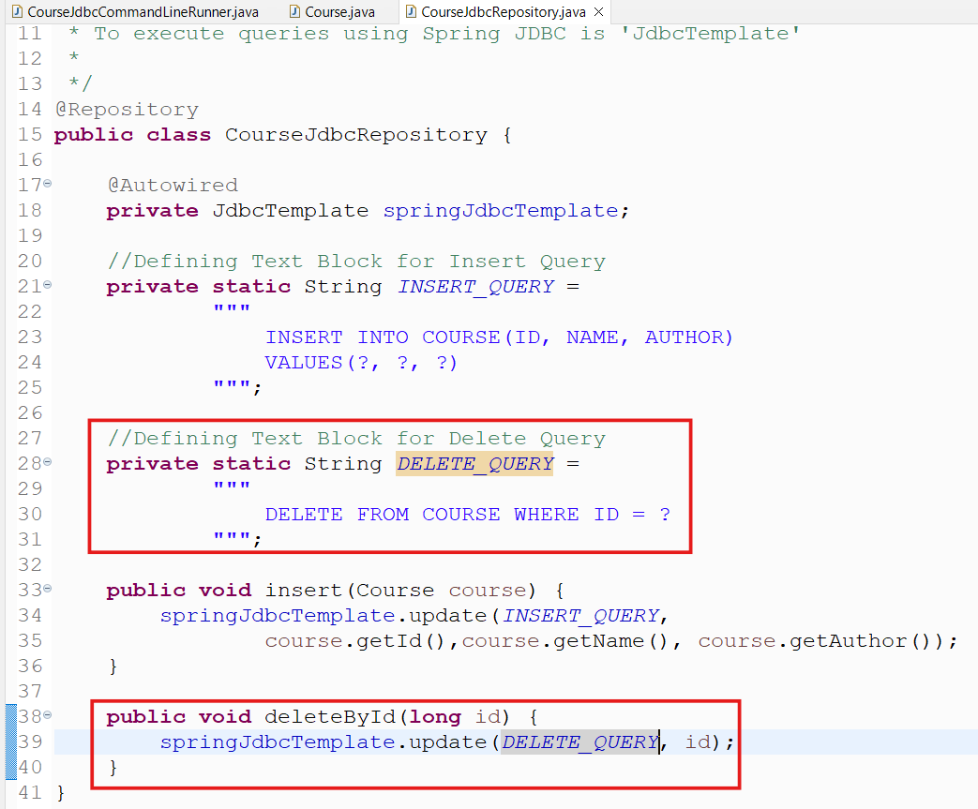

Added call to deleteById method. It will delete the row for the matching ID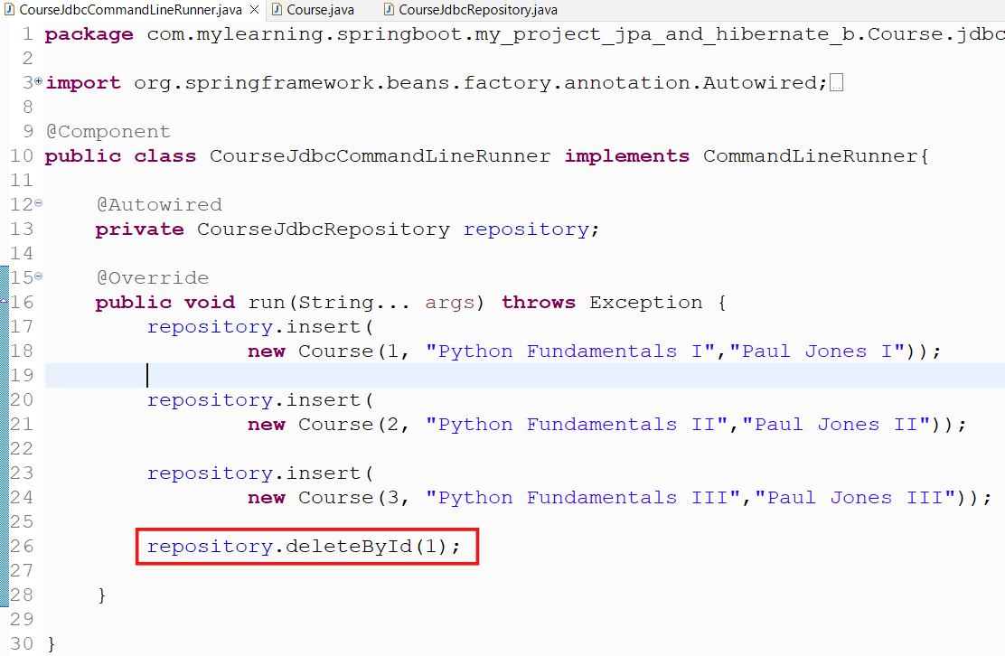

- Launch the application & execute select query to see the results: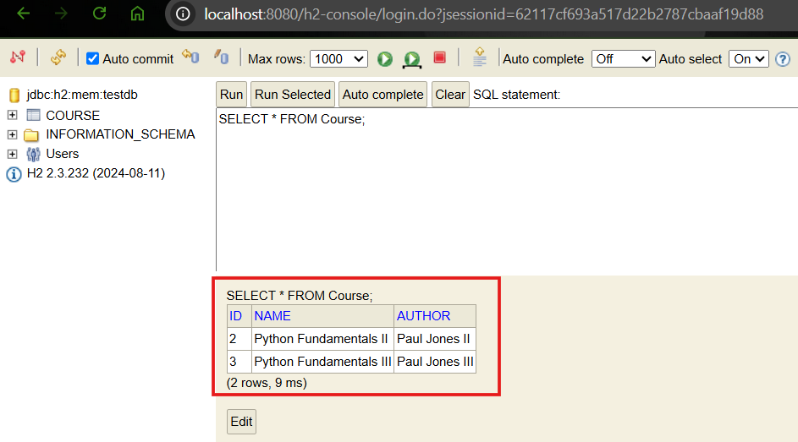
We can see that immediately after addition of the data, the row for ID=1 has been deleted. That’s why it is not returned by SQL.

ST07: Querying data using Spring JDBC

- Update the Repository class to add the selectById method. It will return the result for the id passed as an argument.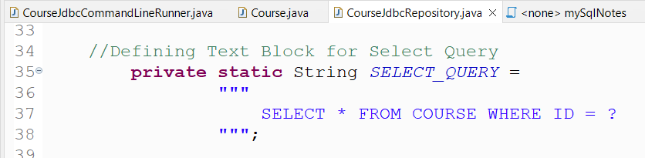

In the case of a Singleton Query we can use the 'queryForObject' function to get the result from the table.

This function takes 3 parameters as input:
- SELECT_QUERY
- Row Mapper - to map the result set returned
- id (Key value)

It returns a Result Set. Result Set can be mapped to the Bean(Class Object) using Row Mapper

Since in our case the Columns present in the table & Bean have an exact. It allows us to use 'BeanPropertyRowMapper'.

- Add a call to the selectById method to get the results on startup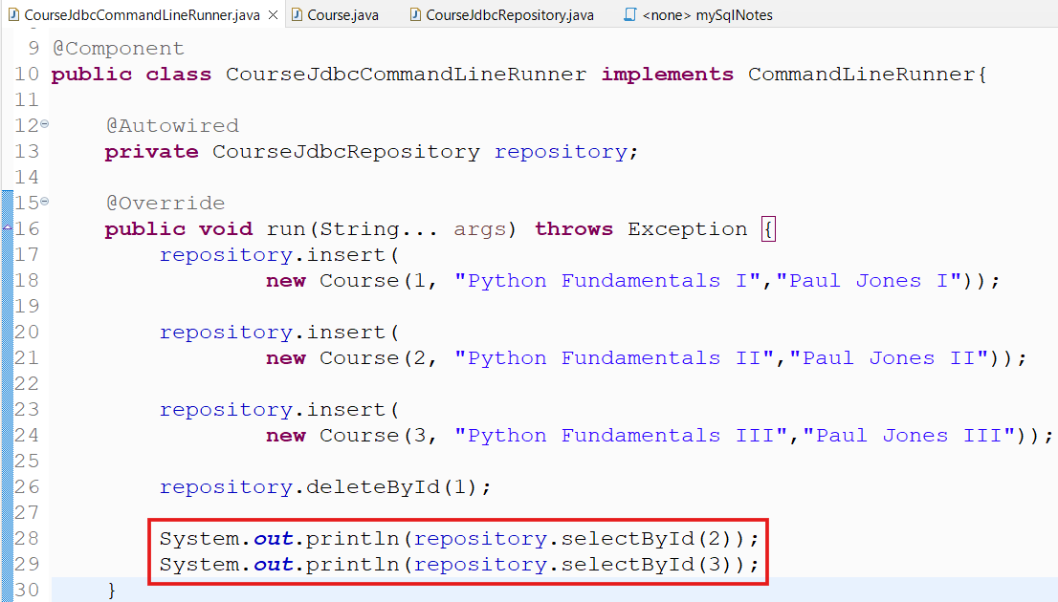
- Launch the application to see the results: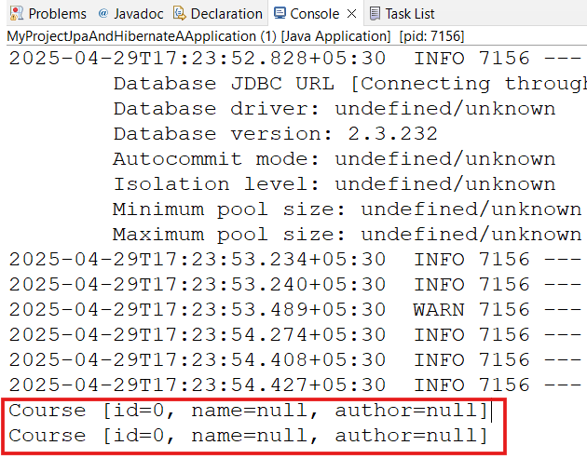
- Since we have set up only getters in the Course class, we are getting results as zero & null because the results are not getting set in the absence of setters. Include setters in the Course class & relaunch application: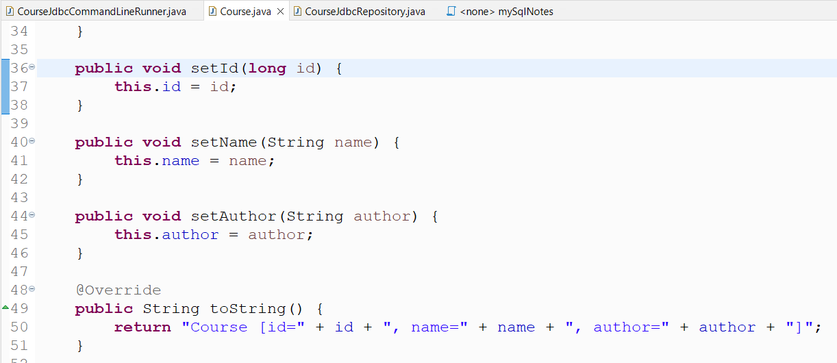

The expected results has been returned
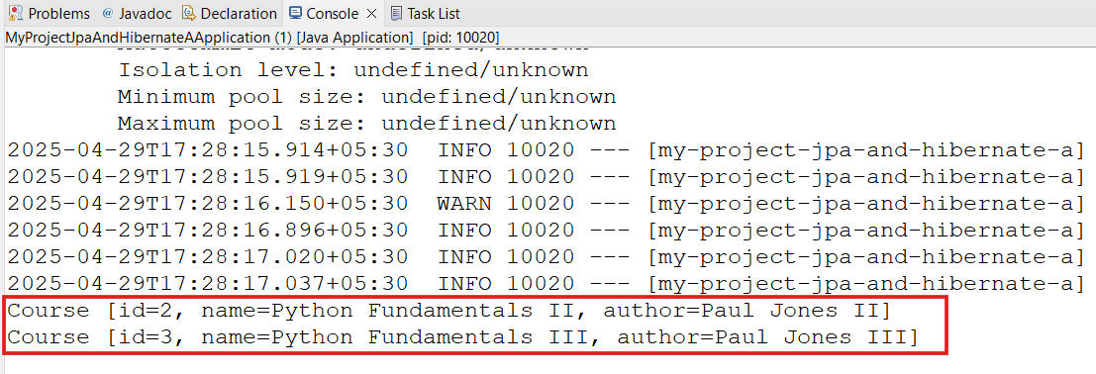

ST08: Getting started with JPA & Entity Manager

In the above 2 steps, we have seen that we can define the queries & pass the query, key values as arguments to communicate with the database.

SInce we had just one table to manage, but as the number of tables increases, the complexity of queries & probably the number of queries will increase as per the requirement.

In such cases, JPA uses a different approach:
- It maps our Course Bean directly to the table & its columns.

- This mapping will be used to Manage the Database without writing a SQL.

- Entity Mapping(Bean to Table Mapping)
  - The Course Bean is called as an ‘ENTITY’ represented by Annotation - ‘@Entity’
  - In case the name of the Bean & the table is different, then we can map the Bean class by using Annotation - ‘@Entity(name=’tableName’)’

- Primary Key(@Id Annotation) Mapping
  - The field in the Course class Bean can be mapped with the Primary Key of the table by using Annotation - ‘@Id’

- Column Mapping (‘@Column’)
  - The column mapping is done using Annotation - @Column(name=’columnNameInTheTable’).
  - In case the name of the field in Bean class exactly matches with the table column, we can just specify Annotation - ‘@Column’.

Example:
- Course class
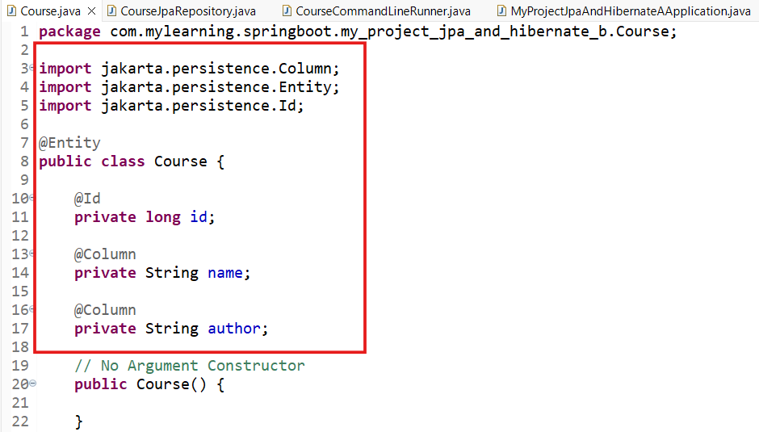
Note: All the imports will be done from ‘jakarta.persistence’ package
- New JPA Repository for the Entity Manager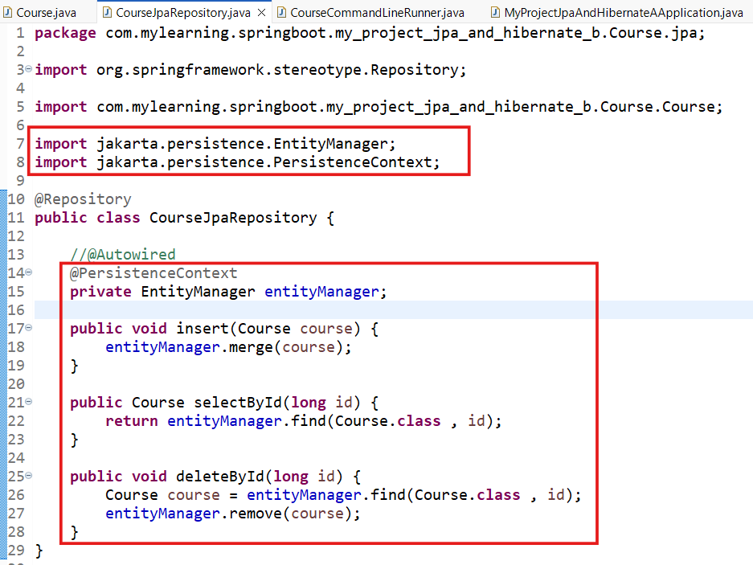
DB Operation | EntityManager Function | Argument
Select (Find) | find | Course object,..,etc
Insert (merge) | merge | Course class & Primary key, ..etc
Delete | remove | Course Object
Note: for Delete Operation, first we need to find the row & then delete it. Also @PersistenceContext is more specific than @Autowired, is recommended to use

- CourseCommmandLineRunner class - Update the Repository class to CourseJpaRepsitory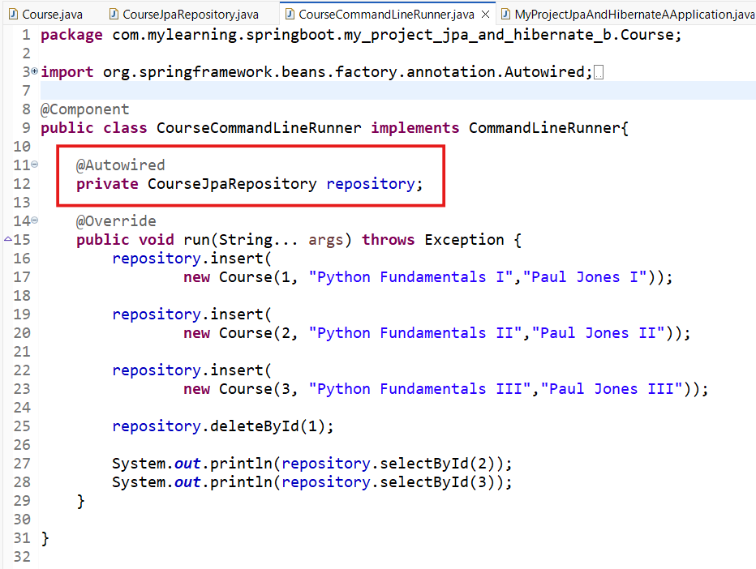

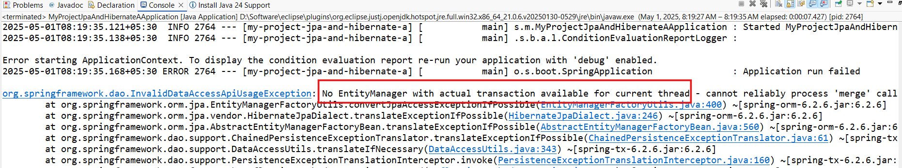

Since we have not enabled the Transaction on the Repository, we got the above error.
Lets add & relaunch the application.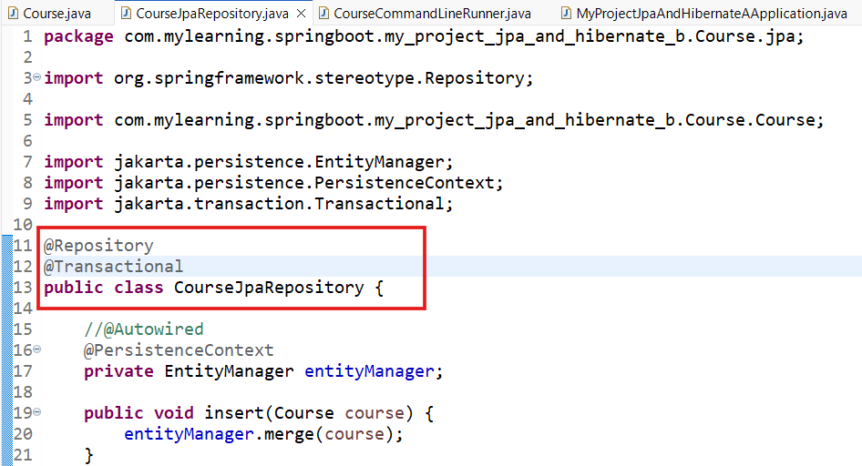

We can see that the selected rows has been returned on startup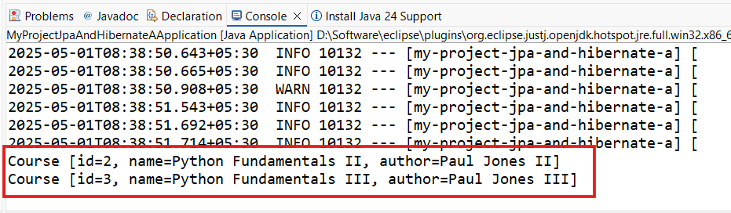

Lets query the DB in H2 console: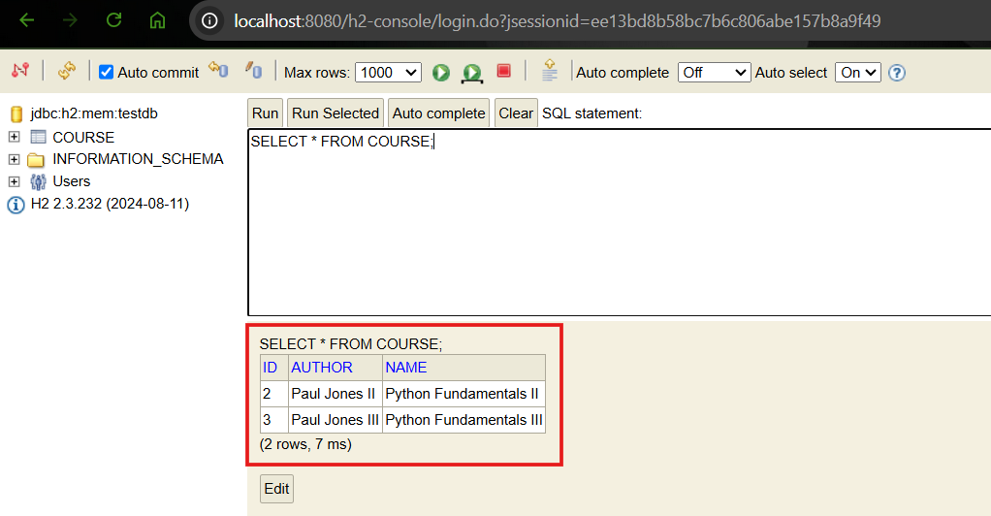

If we want to see the SQL being executed by jpa, we can add a property
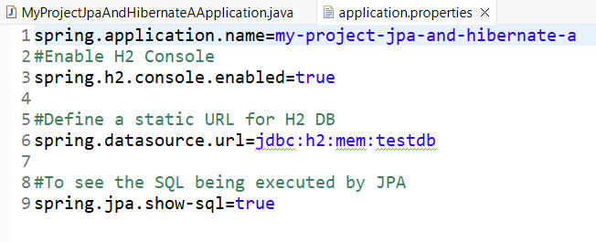
We can relaunch the application, it will start showing the SQL being executed ON STARTUP.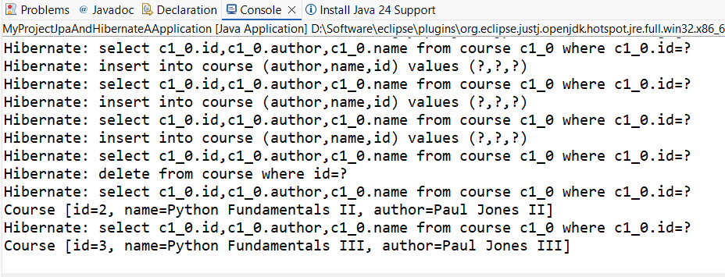

ST09: Exploring the Magic of JPA

- Using JPA, we do not need to write the SQL.
- It maps the Course Entity to the Table Entity directly by removing complexity in writing SQL.
- To map the Entity, Entity Manager is used.
- Entity Manager allows operations like find (for selecting data from database), merge (for inserting data into the database), remove(to delete data from the table) etc.

ST10: Getting started with Spring Data JPA

- It makes JPA even more simpler
- We do not need to worry about even Entity manager, Spring Data JPA will take care of it.

ST11: Exploring Features of Spring Data JPA

ST12: Understanding Difference between Hibernate & JPA

